Fig. <$n:figure:SyncVsAsync-main> contains a diagram of a simple system.

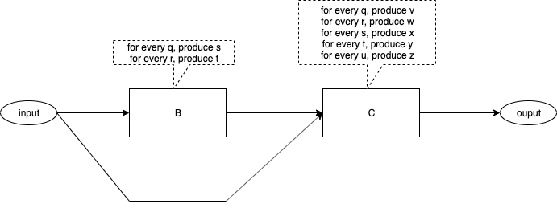
Fig. <$n:figure:SyncVsAsync-main> A Simple System

The diagram contains one input port and one output port.

The diagram contains two components. The algorithms for the boxes are straight-forward. The algorithms are stated in terms of what each box outputs when inputs arrive at that box.

The flow of data within the diagram is shown by arrows.

It appears that we have plugged two software components together to form a system.

